**IntelliJ TypeScript Settings**

1. Verify you have installed TypeScript and TSLint globally using NPM.

* npm install g typescript tslint

1. Configure TypeScript settings for IntelliJ.

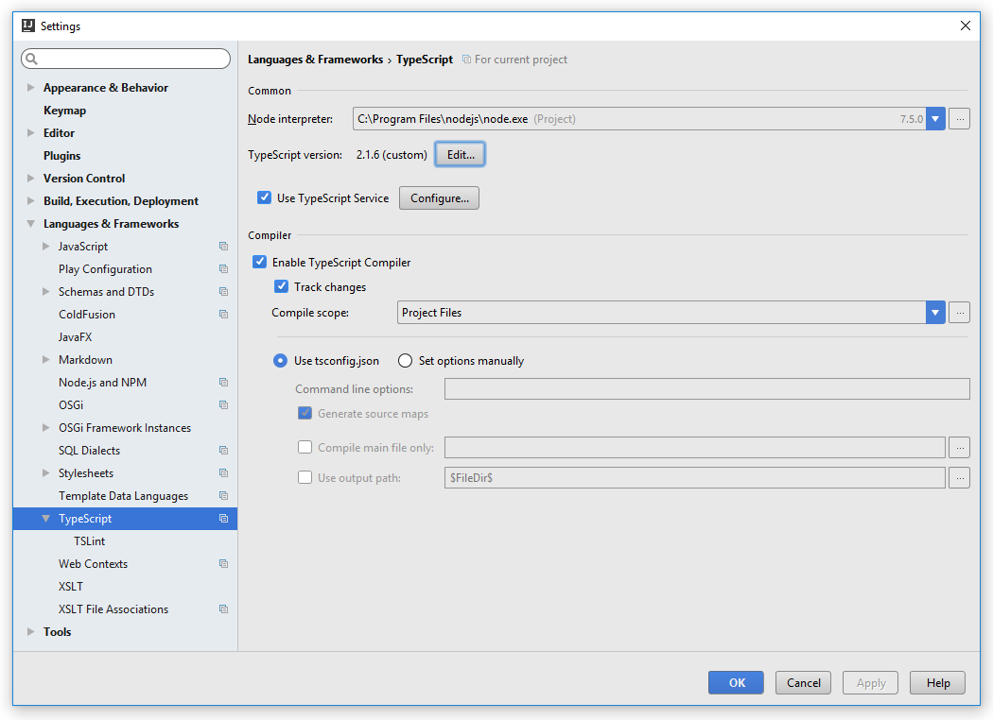

1. Configure IntelliJ to use global TypeScript version (replace Tony with your user name).

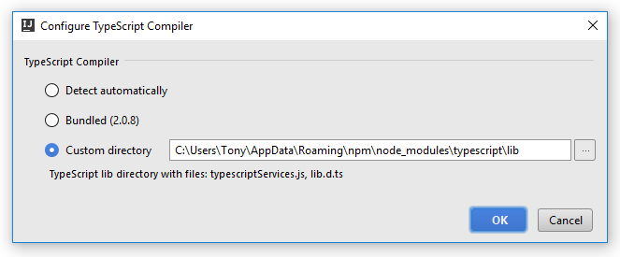

1. Configure TSLint settings for IntelliJ.

